Warrior T-Shirts
Wear your school spirit shirts on designated days!

Name: ____________________ Homeroom: _______ Phone: ______________

Shirts are $15 each (unless otherwise noted) and available for purchase.
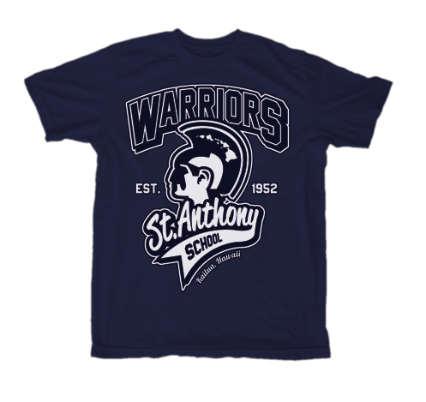
Checks payable to SASPTSG.

Youth Tee
Colors | 4T $10 | XS  $10 | Small | Medium | Large | XL
Red
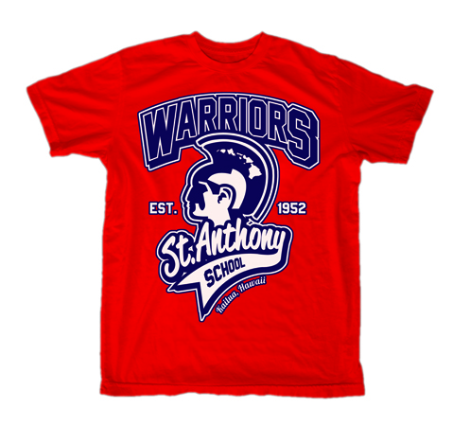
Blue

Adult Tee
Colors | Small | Medium | Large | XL | 2XL | 3XL
Red
Blue
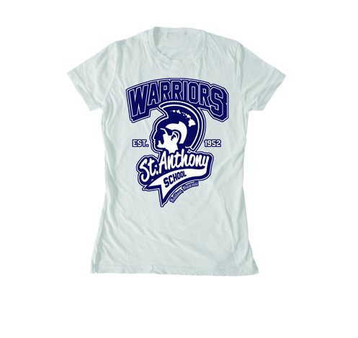

Women’s Cut Tee $10
(Women’s shirts are form-fitting, longer in length and run small)
Colors | Small | Medium | Large | XL
Red
White

Vintage T-Shirts (available in limited quantities and sizes)
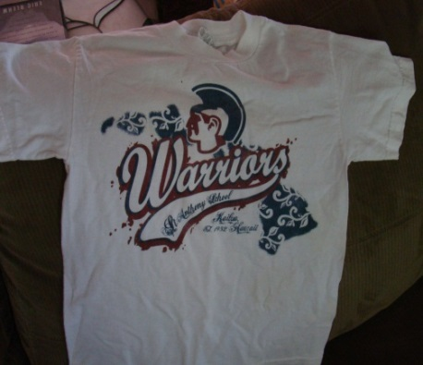
Only $8 !!
Youth Large – White (6)
Adult Small – White (3)
Adult XL – Red/Blue/White (3/1/6)
Adult 2XL – Red/Blue/White (2/3/20)

# in parentheses denotes quantity available
as of 3 September 2014

Total Amount Due $ __________

